An Abstract On

College Alumni Connect & Management System

By

R.SUPRAJA 224G1A05B1
C.V.RAJASEKHAR REDDY 224G5A05C2
C.NARASIMHULU 224G1A0558

Under the esteemed guidance of
Dr. M.RANJIT REDDY, M.Tech., ph.D.
Professor

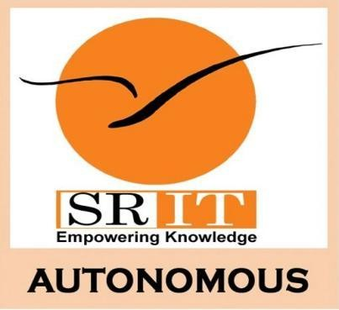

DEPARTMENT OF COMPUTER SCIENCE AND ENGINEERING SRINIVASA RAMANUJAN INSTITUTE OF TECHNOLOGY
(AUTONOMOUS) ANANTHAPURAMU
(Affiliated to JNTUA and Approved by AICTE, New Delhi)
(Accredited by NAAC With ‘A’ Grade& Accredited by NBA (EEE, ECE & CSE))

2025-26

Project Coordinator Head of the Department

College Alumni Connect & Management System

ABSTRACT

The College Alumni Connect and Management System is designed to strengthen communication and engagement among Students, Faculty, Staff, Alumni, and Administrators through a unified digital platform. The system provides a dedicated Student Portal and Alumni Portal to support efficient information sharing and seamless interaction within the academic community.

Alumni can update career details, provide feedback, mentor students, share opportunities, and actively participate in institutional activities. Students and faculty can track alumni achievements, submit feedback, and seek academic or career guidance from experienced graduates. Administrators manage user data, monitor feedback, configure portal settings, and ensure secure and efficient system operation through a dedicated Admin Panel.

A key feature of the system is the AI-based Skill Matching Module, which analyzes students’ skills, interests, and career goals to identify the most suitable alumni mentors. The system automatically sends recommendations and notifications, enabling meaningful student–alumni connections and enhancing personalized guidance.

Overall, the platform improves alumni engagement, empowers students with valuable mentorship opportunities, and streamlines communication across the institution, contributing to a more connected and collaborative academic ecosystem.

PROJECT GUIDE
1.224G1A05B1
2. 234G5A05C2
3. 224G1A0558

